Animesh Parab T2-T21 88

ASSIGNMENT - 06

AIM- To understand terraform lifecycle and to Build, change, and destroy AWS infrastructure Using Terraform.

LO MAPPED – LO1,LO3

THEORY-
Terraform is a tool for building, changing, and versioning infrastructure safely and efficiently. Terraform can manage existing and popular service providers as well as custom in-house solutions.
The key features of Terraform are:
• Infrastructure as Code: Infrastructure is described using a high-level configuration syntax. This allows a blueprint of your datacenter to be versioned and treated as you would any other code. Additionally, infrastructure can be shared and re-used.
• Execution Plans: Terraform has a "planning" step where it generates an execution plan. The execution plan shows what Terraform will do when you call apply. This lets you avoid any surprises when Terraform manipulates infrastructure.
• Resource Graph: Terraform builds a graph of all your resources, and parallelizes the creation and modification of any non-dependent resources. Because of this, Terraform

builds infrastructure as efficiently as possible, and operators get insight into dependencies in their infrastructure.

• Change Automation: Complex changesets can be applied to your infrastructure with minimal human interaction. With the previously mentioned execution plan and resource graph, you know exactly what Terraform will change and in what order, avoiding many possible human errors.
STEPS-
Google Search – Terraform DOWNLOAD

Create a Folder in Your C drive Named AdvDevops
Then Extract The downloaded file in The C drive Folder Named AdvDevops Shown Below
Now search EDIT THE SYSTEM ENVIRONMENT VARIABLES in your windows se

Now click on PATH OF USER VARIBLES, then click on Edit option
Now go to edit and then add new path C:\AdvDevOps

Repeat same procedure for system variables.

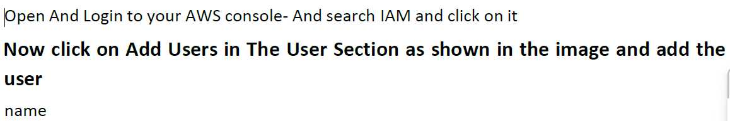

Delete all security keys and csv files.
Delete users and user groups
CONCLUSION –
In this assignment we learnt about the terraform lifecycle, core concepts/terminologies and installation of terraform in windows and creating/destroying an EC2 instance.

